***Report on***

***AllyHub***

***Prepared for***

|  |  |
| --- | --- |
| **Mr. Taslim Taher**  **Assistant Professor**  **Department of CSE** | **Ms. Tasnuva Binte Rahman**  **Lecturer**  **Department of CSE** |

**Course No: CSE 3224**

**Course Name: Information System Design & Software Engineering Lab**

***Prepared by***

**Lab Section: A2**

**Group Name/No: A202**

**ID: 20210104032 Name: Afia Fahmida**

**ID:** **20210104040 Name: Ashikul Islam**

**ID:** **20210104047 Name: Zenun Chowdhury**

***Date: 3 May, 2024***



***Department of Computer Science and Engineering***

**Risk Analysis**

Implementing a platform for developers and client’s smooth interaction using C#, ASP.NET Core MVC framework and MySQL database involves several risks that need to be identified, addressed and analyzed. Here's a breakdown of the risk analysis for this project:

*Security Risk:* Weak passwords might lead to hijack attack and unwanted data leakage from SQL database causing privacy issues.

*Implementation of Complex Features:* Idea of using C# in back-end with mixture of ASP.NET MVC framework might lead to difficulty in implementing complicated features as the resources for this language and framework is pretty old versioned.

*Compatibility Risk:* Our platform may encounter usability troubles in different browsers due to the variance of framework we are using.

*Maintenance Risk:* We have not decided to add an admin panel yet so maintenance like debugging and reinstalling’s if needed will have to be done by our team. But it will cause problems if any of the team member’s discontinues.

*Data Integrity Risk:* Wrong integration of SQL queries or C# code can cause troubles in data storage and retrieval leading to data corruption and loss.

*Competition in Market:* Our platform shares quite similar ideas with other existing platforms like LinkedIn, Glassdoor etc. which will rise high chances of loosing market due to poor maintenance.

**Challenges**

*Implementing payment gateway*: We have a feature of auto payment. But without a payment gateway subscription that’s not something that can be promised.

*Short Time Tenure:* Due to shortage of given project time implementation of certain desired features might lack. But it can be implemented further in near future.

*Designing user Friendly UI/UX:* This was our prime objective and still making a user friendly UI/UX without having any good idea on our future users as everybody’s comfort user experience is not same.

Robust Back-end Integration: Results of designing a smooth backend using C# and MySQL database is marvelous but is also pretty challenging. Monitoring use of incorrect Models, views, missing headers, incorrect implementation of transactions etc. will call troubles upon us.

**Workload Distribution**

**Gantt Chart**

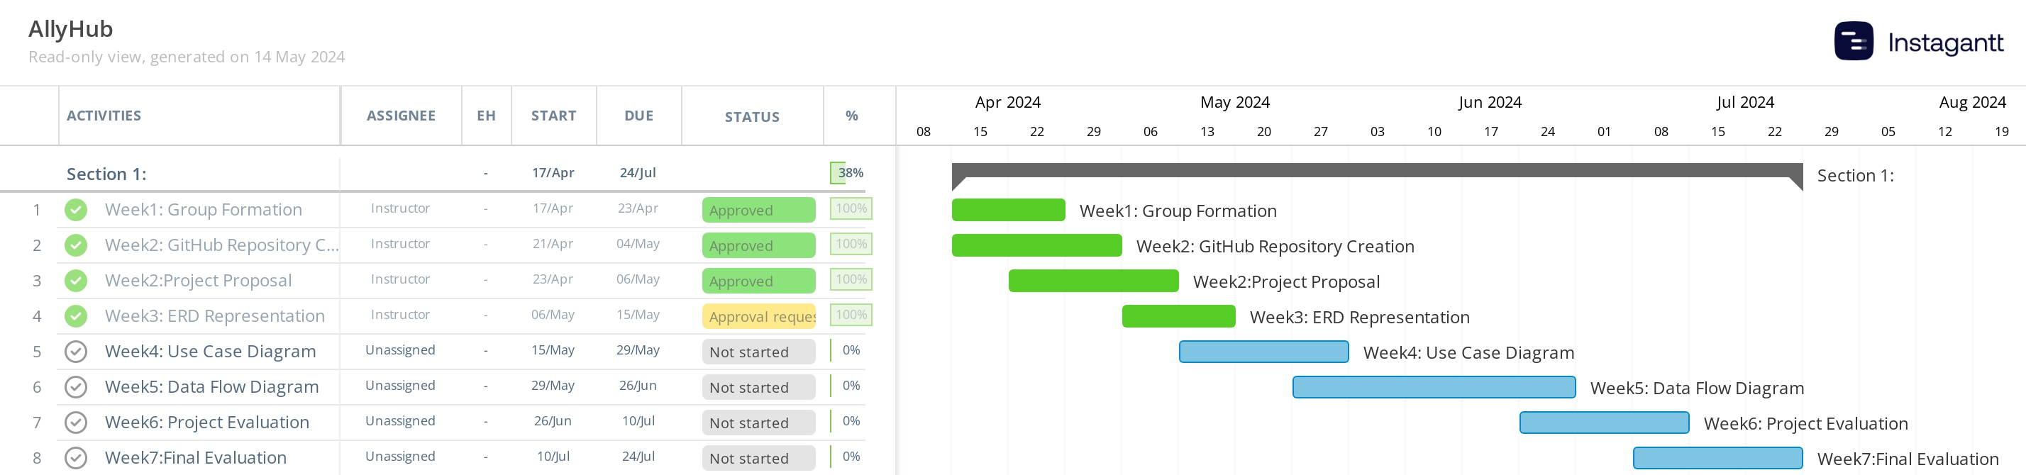

**Entity-Relationship Diagram**